Sex

Marltal Status

Nationality

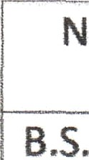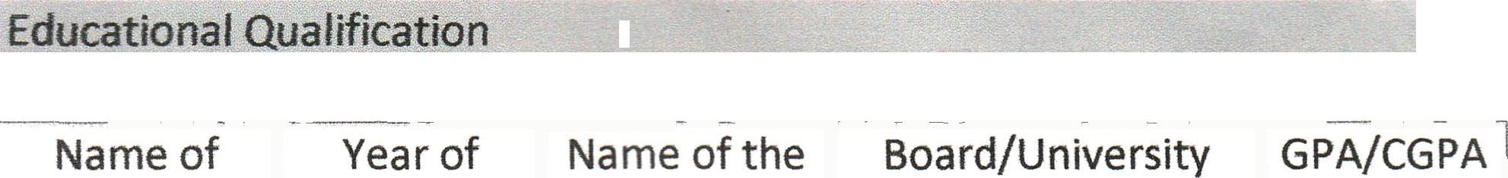

Exam

Passing

Institution

CURRUCULUM VITAE

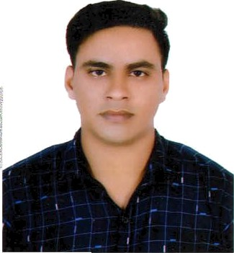Male Unmarried Bangladeshi

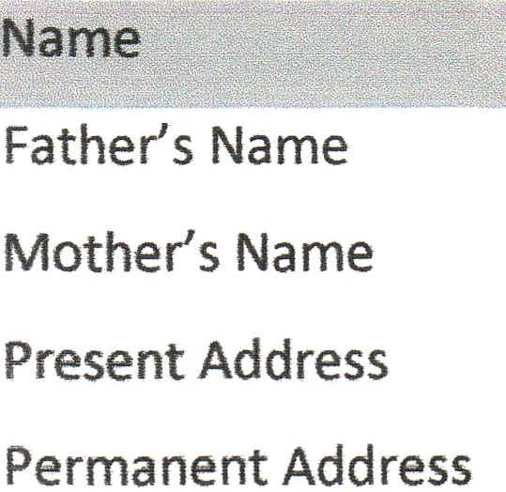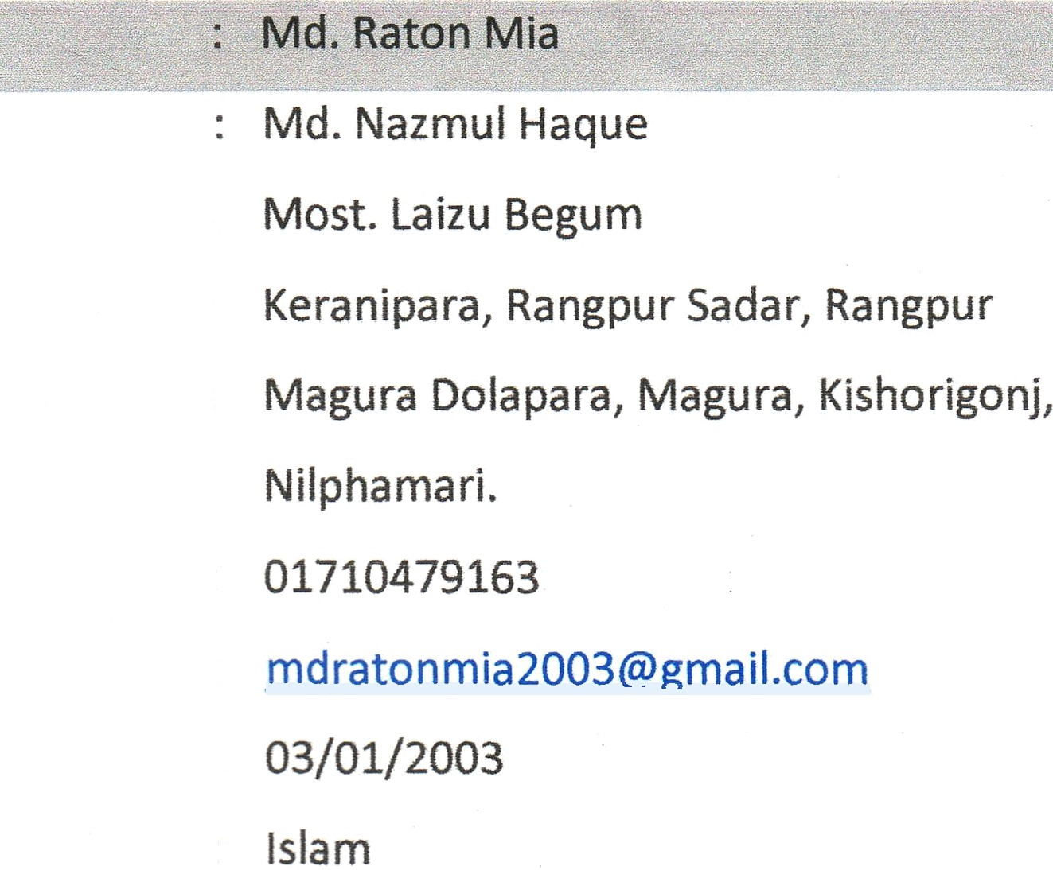

Mobile Number E-mail

Date of Birth

Religion

|  |  |  |  |  |
| --- | --- | --- | --- | --- |
| B.S.S (Hon's) | 2nd Year 1st | Begum | Begum Rokeya | 3.00 |
|  | Semester | Rokeya | University, Rangpur |  |
|  | (Running) | University, |  |  |
| H.S.C | 2020 | Dr. Asadur | Dinajpur | 4.42 |
|  |  | Rahman  College |  |  |
| S.S.C | 2018 | Magura High  School | Dinajpur | 3.94 |

Extra Curriculum Activities:

Member of BRUDA (Begum Rokeya University Debate Association)